Photress

Use-Case Specification: Thumbnail View

Version <1.1>

Revision History

|  |  |  |  |
| --- | --- | --- | --- |
| **Date** | **Version** | **Description** | **Author** |
| 17.10.2013 | <1.0> | First version of Thumbnail View | Benny Görzig |
| 31.10.2013 | <1.1> | Added Mockup Added Narration | Benny Görzig |
|  |  |  |  |
|  |  |  |  |

Table of Contents

1. Thumbnail View 4

1.1 Brief Description 4

2. Flow of Events 4

3. Special Requirements 4

4. Preconditions 4

5. Postconditions 4

6. Extension Points 4

7. Mockup 5

8. Narration 6

Use-Case Specification: Thumbnail View

# Thumbnail View

## Brief Description

The Use Case “Thumbnail View” is accessible for every kind of user group. Hereafter the actor will be called “Spectator”. The spectator will be able to view pre-generated thumbnails of the pictures he wants to look at.

# Flow of Events

E:\SoftwareEngineering\TeamDrive\Spaces\Projekt 'Photress'\Dokumente\AD - Thumbnail-View.emf

# Special Requirements

N.a.

# Preconditions

The spectator has to request the gallery of an activated user. Additionally, for viewing thumbnails this user has to have images uploaded in his gallery.

# Postconditions

The spectator will see a generated gallery on the website with thumbnails of pictures the user has uploaded.

# Extension Points

N.a.

# Mockup

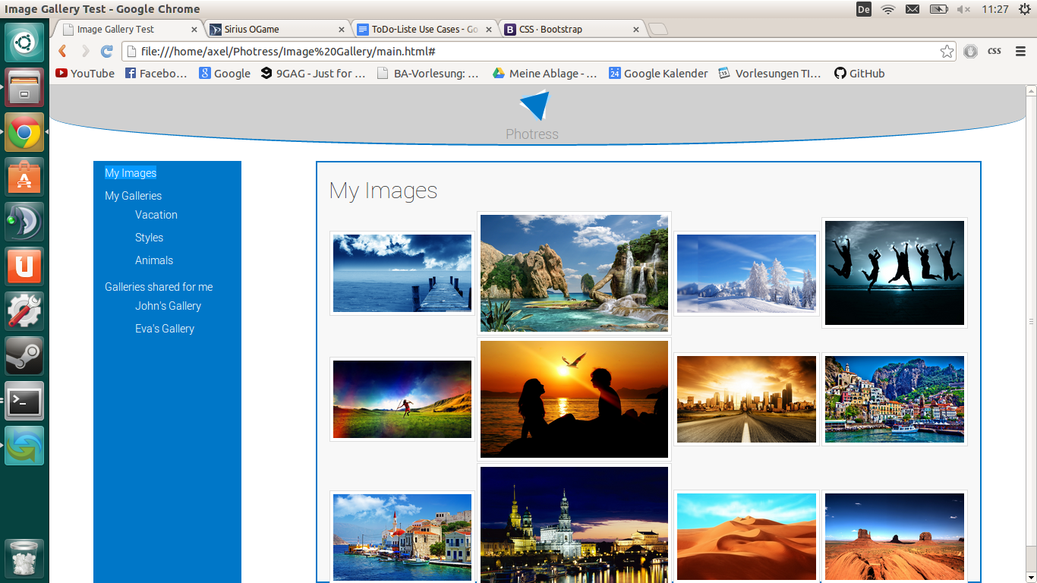

# Narration

Feature: Thumbnail_view

As a visitor (or any other defined role)

I want to see small previews of images

In order to get an overview of the images

Scenario: Gallery is displayed in Thumbnail-view-mode

Given I click on the link to the gallery

And Gallery uses thumbnail view

And Gallery contains any visible images

And the container holding the thumbnails has got id "container"

When the page finishes rendering

Then "#container" contains img-tags showing the thumbnails

Scenario: No images available

Given I click on the link to the gallery

And Gallery uses thumbnail view

And Gallery does not contain images

And the container holding the thumbnails has got id "container"

When the page finishes rendering

­­­­­ Then "#container" contains "No Images available"